DDIC source channel level and timing test error correction using channel loading capacitance auto diagnostic and mathematical compensation

James JinSoo Ko¹, Bokhyun Han²
^{R.O.Korea}
(E-mail: Jinsoo.Ko@cohu.com, Bokhyun.Han@cohu.com,)

JunHo Lee³,Chanhyung Jung⁴, and MinSu Baek⁵
^{R.O.Korea}
(E-mail: Petrus.Yi@cohu.com, Chan.Jung@cohu.com, Liam.Baek@cohu.com)

ABSTRACT
A display driver IC (DDIC) has hundreds of source driver outputs, and individual channels must drive video pixel signals within strict level and timing, and the level and timing deviation specifications between channels are also very strict. Therefore, to test a signal to specification, need to be used multi-channel digitizers or comparators those are designed with high precision and highly symmetry. However, the long transmit signal line from the driver output pin to the test equipment capture input port causes high capacitance variation between channels, making it difficult to accurately test source driver voltage levels and slew timing. In this paper, proposing a solution to improve capacitance changes between capture channels, including load board signal lines, by adjusting the capacitance directly on the channel card or load board, or by mathematically compensating the source signal data using automatic channel capacitance diagnosis technology. This technology also reduces channel card and load board design, manufacturing, and test costs, achieves more accurate test results, and provides the ability to screen of failed channels having too high or too low capacitance. It is also possible to automatically find bad contacts in hundreds of source channels with pitch or pad spacing of only about 10um.

Keywords: DDIC, FPD,OLED,LCD,TFT

- INTRODUCTION

DDIC (Display Drive Integrated Circuit) is an integrated circuit chip that controls the panel and display method of LCD panels and AMOLED panels. As panel displays and data transfer rates increase, requirements for driver ICs are also increasing.

Figure 1. The OLED DDIC is one of the main control components of the panel. Its main function is to control the light and color of the screen and transmit driving signals and data as electrical signals to the display panel to display text, photos, and other video information on the screen.

DDIC drives the display panel and transmits image data through electrical signals. In Figure 2, the location of the DDIC is differentiated depending on whether it is PMOLED or AMOLED.

For PMOLEDs, the DDIC inputs current into both the horizontal and vertical ports of the panel. Upon current excitation, the pixel dots turn on, and the brightness can be controlled by controlling the current level.

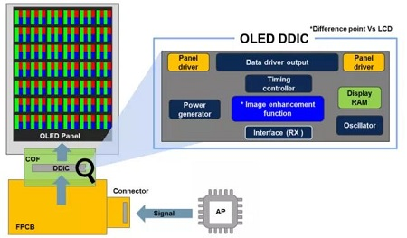

Figure 1. OLED DDIC

In the case of AMOLED, each pixel corresponds to a TFT layer (Thin Film Transistor) and a data storage capacitor that controls the gradation of each pixel.
Each pixel is made up of several subpixels representing the three primary RGB colors (R red, G green, and B blue).

The pixel voltage values (or on-state time duty cycle) of the TFT are transmitted one by one according to a certain time rhythm in a scanning manner.
Some of the ICs responsible for scanning are DDICs, some are responsible for horizontal, and some are responsible for vertical. As shown in Figure 3, the one responsible for horizontal work is called the Gate Driver IC (also called Row IC), and the one responsible for vertical work is called the Source Driver IC (also called Column IC).

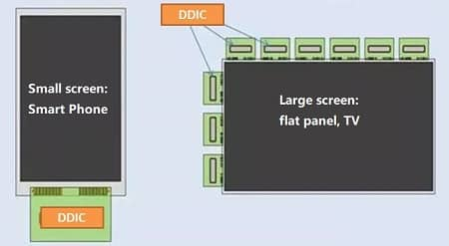
Figure 2. DDIC location

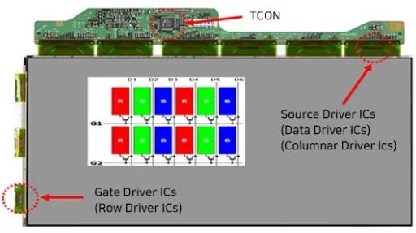
Figure 3. DDIC gate and source driver location

RELATED WORK

To verify the V/I driving specifications of all hundreds of DDIC source drivers as shown in Figure 4, which are ideally designed to have equal functionality and power symmetrically. To test, first set all the source drivers' levels to 8~17V step signals and drive all channels simultaneously to the connected digitizer or comparator on the capture equipment channel card of the ATE test head, as shown in Figure 5.

Typically, comparators are used in production testing to save test time, and digitizers are used in evaluation testing.

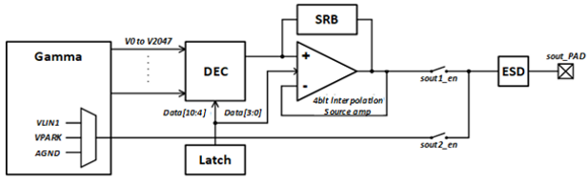

Figure 4. DDIC Source Driver block diagram

In this case, if the source output series resistance is Rsrc and the total capacitance from the source output pin to the capture channel comparator or digitizer input is Cn, the step signal response follows equation (1).

Vsrc(t) = 1-Exp [- t/(Rsrc*Cn)] –(1)

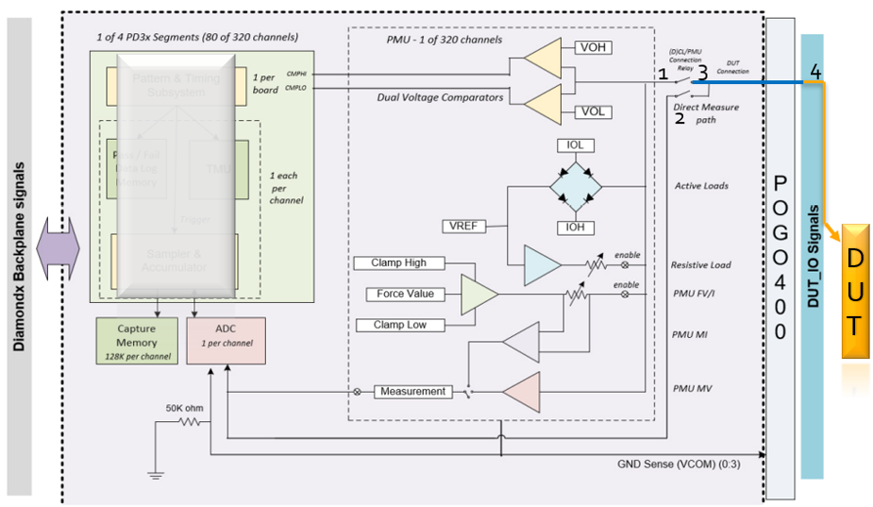

Figure 5. Source driver capture channel and connection diagram

If the DDIC source channels are designed and built uniformly and the signal paths to the capture equipment are ideally all identical, the voltage levels of each source driver are expected to be the same at the same time by the capture equipment's digitizer or comparator. However, in real situations, this relationship is not true. Firstly, if the load board design is asymmetrical concerning pattern length and width, the capacitance of each signal line pattern on the load board will not be equal, and secondly, the connected blocks of the instrument channel card containing the single path and pogo block and PCB pattern are not equal or symmetrical, the capacitance between the channels of the capture instrument will not be equal, so the capture source voltage level cannot be accurately tested and the results will not be the same.

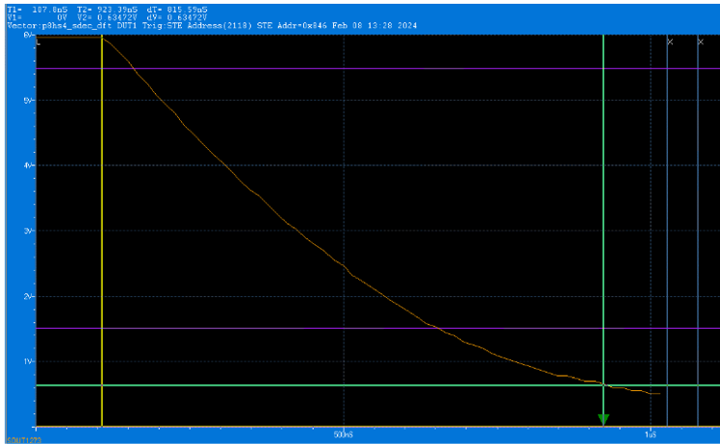

Figure 6. DDIC source driver high to low step signal
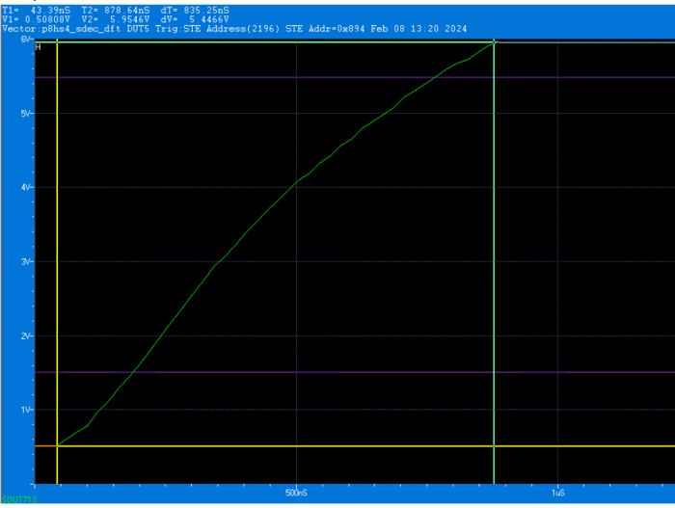

Figure 7. DDIC source driver low to high step signal

The signal path of a capture device inside a channel card is much more complex, with multiple layers of connections and relays and other complex functional blocks than a load board path designed as a simple single signal line without any passive or active components. These load board or capture instrument designs introduce unexpected line or path capacitance, making it impossible to capture accurate source driver signal levels or slew times as shown in Figure 8.

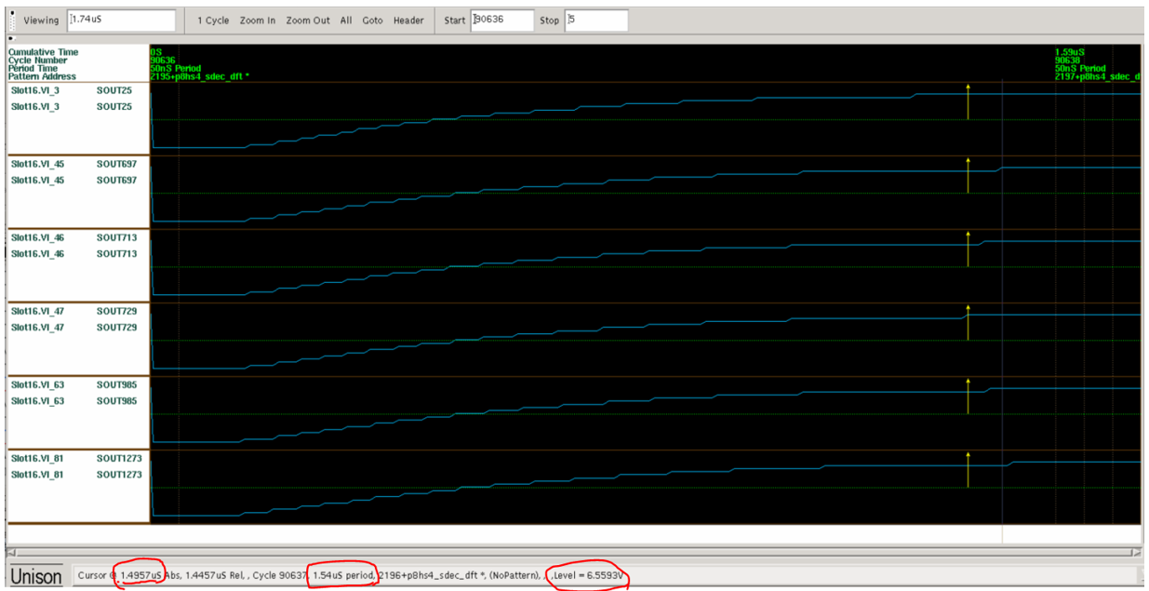

Figure 8. DDIC source driver low to high step signal for multiple channels and Vsrc level variance at td

PROPOSED IDEA and RESULT

  - Symmetrical Load Board source signal line design

First, the simplest way to reduce the variation in capacitance of signal lines between channels on the load board is to design the length, width, and thickness of the signal lines to be symmetrical as much as possible. This is controllable, and by redesigning all signal path symmetries to have the same length and geometry, much improved results can be obtained, as shown in Table 1 and Figure 9. The line capacitance variation of the load board has been reduced from 19 pF to 4.06 pF. In fact, the new design is more compact, reducing the average capacitance across all lines from 56.4pF to 48.07pF.
Table 1. Source signal line design on lard board (unit: pF)

Figure 9. Source Driver Signal line design on loard board (unit: pF)

  - Adjusting all capture instrument channels having the same capacitance

The way needs a lot of measuring of each channel capacitance by external instrument. After capturing the capacitance of all the channels listed it selects the highest value and adds a capacitor the each channel to have the same capacitance with the reference channel.

It is very time-consuming hard work. The line capacitance variation of the load board has been reduced from 18.2pF to 5.6pF. In fact, the new design is more compact, reducing the average capacitance across all lines from 77.8 pF to 75.9 pF as shown in Table 2 and Figure 10.

Table 2. Capture channel capacitance adjusting (unit: pF)

Figure 10. Capture channel capacitance adjusting (unit: pF)

  - Channel capacitance diagnostic and mathematical signal level and timing compensation
Physical capacitance compensation takes a lot of time and money. Therefore, if we can measure the total capacitance of each channel through self-capture channel capacitance diagnostic program allows us to adjust the raw data captured without adding actual capacitors to the signal path and reduce the time and cost.
The charge (Q) stored in a capacitor (C) at voltage (V) is given by
Q = CV – (1)
Also, Q is given by
Q = ∫ i(t) dt – (2)
If the source driver will drive a constant current (Isrc) until the V gets to Vt during delay time (td) by
Q = Isrc * td – (3)
C = Isrc / Vt * td – (4)

So again, if each source signal path has different capacitance values (Cn), when the source channels drive the same current level to the instrument's digitizer or comparator, the voltage levels (Vn) captured at each source output at the same latency (td) will all be different as equation (5). Therefore, knowing the capacitance difference (Cdn) of each capture channel including the load board path from all channel's average capacitance values (Cavg) as equation (6), we can mathematically calculate the compensated voltage level (Vn-com) as equation (7):

Vn = Isrc / Cn * td – (5)

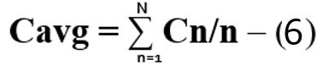

Vn-com = Vn * (Cn / Cavg) – (7)

  - Capture instrument channel and load board capacitance diagnostic technology

Inside the source signal capture equipment, there are several functional blocks, such as time measurement unit (TMU), per-pin voltage driver and measurement unit (PPMU), active load current driver, comparator, digitizer, and resistor load, as shown in Figure 5. Channel capacitance (Cn) diagnostics can be calculated using an active load current source (Ia) and testing (Vt) at time (td) each line using equation (8):

Cn = Ia / Vt * td – (8)

3.4.1 Channel line 1 (red) capacitance diagnostics shown in Figure 11.
3.4.1.1 Open relays 1 and 2 of the capture channel in Figure 11.
3.4.1.2 Set the effective load current to 1mA and start driving current (Ia or IOL) on line 1 (red).
3.4.1.3 Measure the voltage level (Vt) at 300 ns (td).
3.4.1.4 Calculate the Cn value using equation (8).

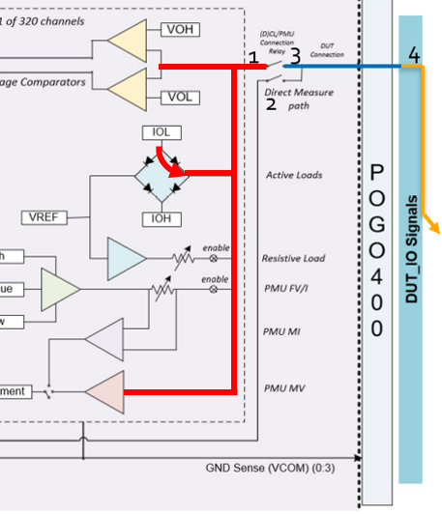

Figure 11. Source driver capture channel and connection diagram

3.4.2 Open or close the channel card in the same way, then attach and detach the load board and test the 2-line (black) capacitance, 3-line (blue) capacitance, and 4-line (Yello) load board capacitance.

Finally, depending on the comparator or digitizer option used, Cn values are applied to mathematically compensate for the driving source voltage Vn-com as equation (7).

- EXPERIMENTAL RESULTS

To utilize capture channel capacitance mathematically to accurately measure source voltage or slew time, must runs the capture channel diagnostic program according to the capture equipment relay open or close in Figure 11 to obtain the source signal line and load board path capacitance as follows:

4.1 Open relays 1 and 2 to measure the red line path (comparator path) capacitance
4.2 Connect relay 1, open relay 2, unload the load board and measure the red and blue line path (interposer and pogo block path) capacitance. As shown in Figure 12, the capture device channel capacitance diagnostic reset is 72.5 pF +/- 2.5 pF.
4.3 Connect relays 1 and 2 without load board to measure the black line (digitizer path) capacitance as shown table 3 (1+2+3).
4.4 Connect relays 1, 2, and the load board to measure the capacitance of the load board as shown table 3 (1+2+3+4).

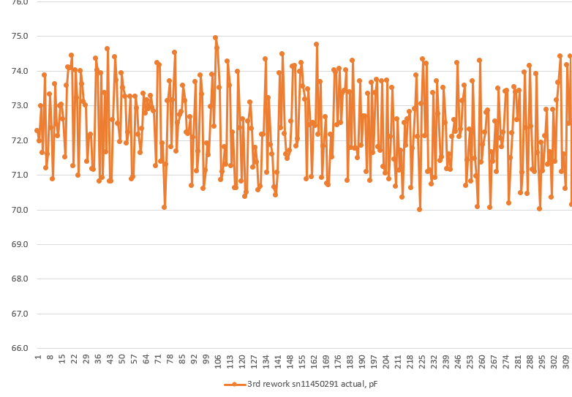

Figure 12. Capture Channel Capacitance Diagnostic Results

Finally, the 320-point orange line in Figure 10 shows the total capacitance of each of the 320 source signal paths from the probe needle tip to the instrument's capture channel comparator. This is measured by driving a fixed current (IOL or Ia) from each channel's active load to the source signal path, including the channel card and load board paths, and then measuring the delay time (td) for the ramp signal to reach the target voltage level. To measure the delay time td, a comparator, and timer inside the capture channel card were used.

These techniques and measurement steps 4.1 through 4.4 allow measuring each capture channel and probe card trace capacitance as shown in Figure 13 and Table 3.

Source pin only (Ch1~166) | Channel (1+2+3) | Channel + P/C path (1+2+3+4) | P/C Path only (4)
MIN | 73.679082 | 121.562170 | 46.096187
MAX | 78.869085 | 127.779644 | 50.158344
AVG | 76.222149 | 124.293455 | 48.071306
MAX-MIN | 5.190003 | 6.217474 | 4.062157

Table 3. Capture channel and probe card capacitance diagnostic results after adjustment (unit: pF)

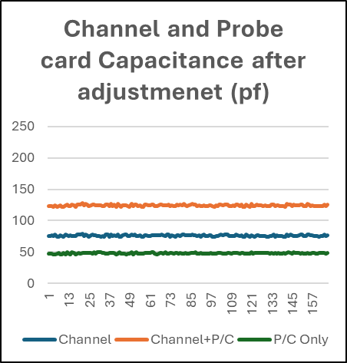

Figure 13: Capture channel and probe card capacitance diagnostic results after adjustment

CONCLUSION

The self-channel capacitance diagnostic method is not only used for source channel voltage and timing testing and improving test accuracy but also as a channel card error check or load board docking contact failure diagnostic tool. Adjusting the 320-capture channel capacitance by adding additional capacitors in the channel path is not an easy task and is prone to mistakes, so automatic simple channel diagnostic techniques are needed and, just in case, apply diagnostic data, can correct test data errors.

The accuracy of diagnostic test results depends on the accuracy of the active load current source or resistive load voltage source. Therefore, before using current and voltage sources for diagnostics function, it must be calibrated using a high-accuracy digital multimeter (DMM) with an accuracy of less than 10nA or 10uV.

When using passive load resistors in the channel card, the resistor values have to be accurately calibrated using a DMM to obtain accurate channel capacitance values.

ACKNOWLEDGMENT

This work was supported by the Cohu test engineering team including Wai-Kong Chen, Bockhyun Han, JunHo Lee, Chanhyung Jung, and MinSu Baek.

REFERENCES

- University of Pennsylvania – School of Arts & Sciences
https://www.sas.upenn.edu › MEMBRANE › capcurr

- Introduciton to DDIC (Displan Driver IC 2022, February 17). Retrieved from https://www.utmel.com/blog/categories/integrated%20circuit/introduction-to-ddic-display-driver-ic
- Lumenlearning
https://courses.lumenlearning.com/suny-physics/chapter/19-5-capacitors-and-dielectrics/

